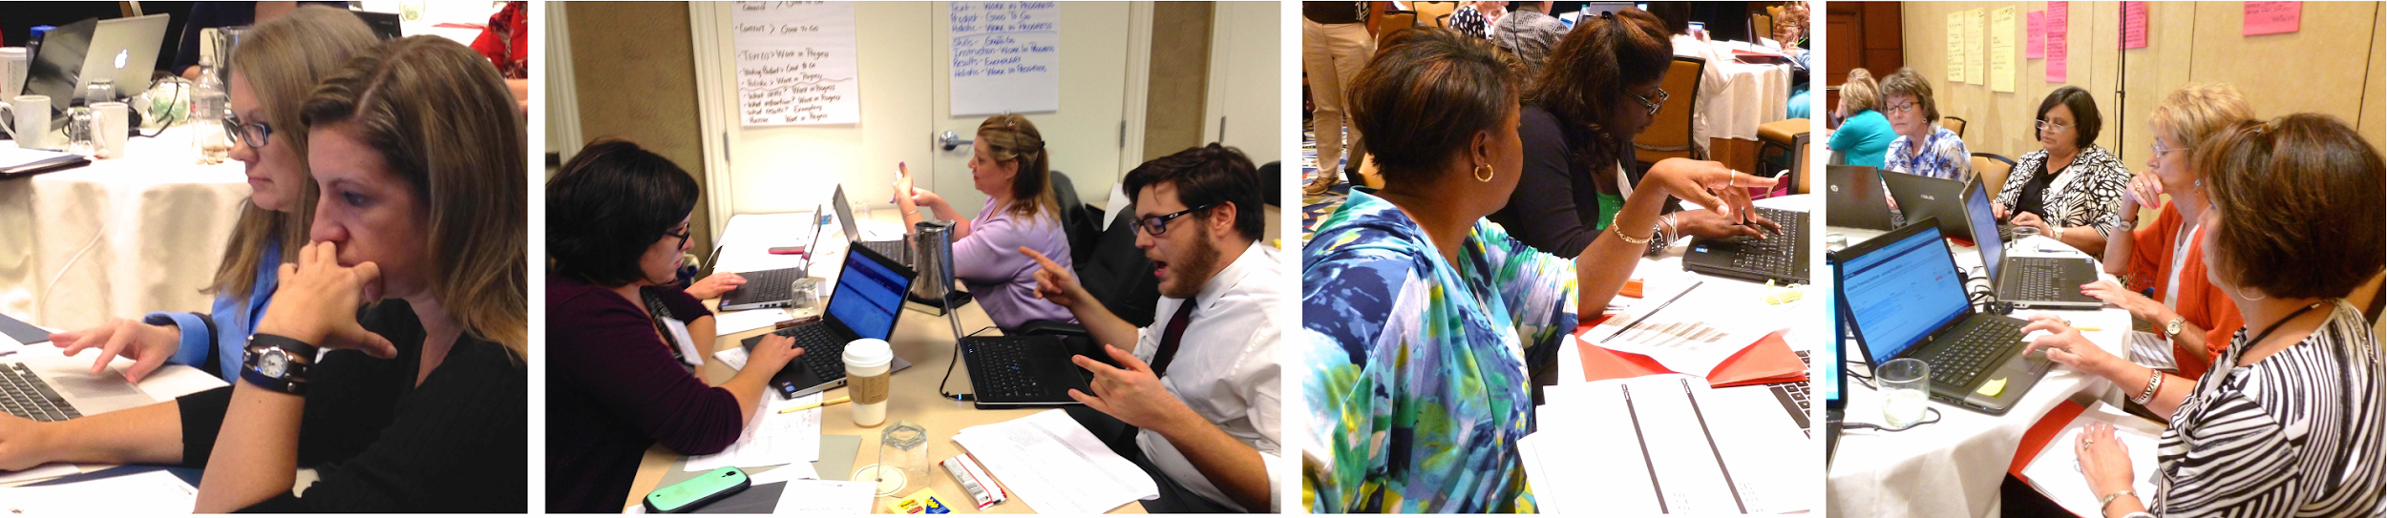

LDC Lead & Learn Fellowship: Submit Your Proposal for the SREB College-and Career-Readiness Standards Networking Conference (July 11-13, 2016) NOW!

Literacy Design Collaborative (LDC) is pleased to invite you and a colleague to apply to become a Lead & Learn Fellow at the Southern Regional Education Board’s (SREB) Fourth Annual College-and Career-Readiness Standards Networking Conference in Louisville, KY. A Lead & Learn Fellow is a member of the LDC community who has successfully implemented LDC and has a story to share with others—in essence, an LDC ambassador! At LDC, we wish to celebrate and share your great ideas with teachers and administrators from around the country so that more students and teachers can experience the power of engaging in thought-provoking work as a community of practice.

Lead & Learn Fellowships will be awarded to 20 teams comprised of two educators. Each team will receive a $1,200 stipend to defray the costs of attending the conference including registration, lodging, and travel.

What do LDC Lead & Learn Fellows do?
Before the conference, LDC Lead & Learn Fellows will be invited to a special pre-conference reception Monday evening, July 11.

During the conference, the two-person team will provide at least one approved conference session, use social media to share what they are learning with others. LDC Lead & Learn Fellows make the most of informal networking opportunities to share their practice and enhance learning for others.

After the conference, Lead & Learn Fellows will contribute to a blog about lessons learned to share with the LDC Community of Practice.

How do I apply for a LDC Lead & Learn Fellowship?
- With a colleague, submit one or more proposals to present at the conference. Please complete this Proposal to Present Form which will be accepted by LDC on or before April 22nd. Successful proposals go beyond introductory level information to target SREB Conference Objectives 2–3:
  - Spread and sustain the LDC framework to all ELA, science, social studies and CTE classrooms within a school.
  - Develop a district plan for bringing on board other teachers in implementing LDC.
**See this brochure for more details about each objective.**

2. Submit your proposal to SREB using their online system or print out the Proposal to Present form and email to summerstaffdev@sreb.org

3. Register for the conference.

How will I know I’ve been awarded an LDC Lead & Learn Fellowship?
LDC will notify your team as to the status of your proposal by email by May 27th and SREB will also notify you regarding the acceptance or rejection of your proposal. Lead & Learn Fellows will be provided with the monetary award prior to the conference in order to minimize out of pocket expenses. The award is contingent upon proposal acceptance and conference registration. Questions? Please contact jennifer@ldc.org or barb@ldc.org.

