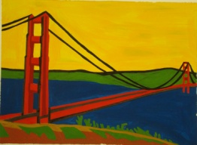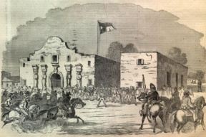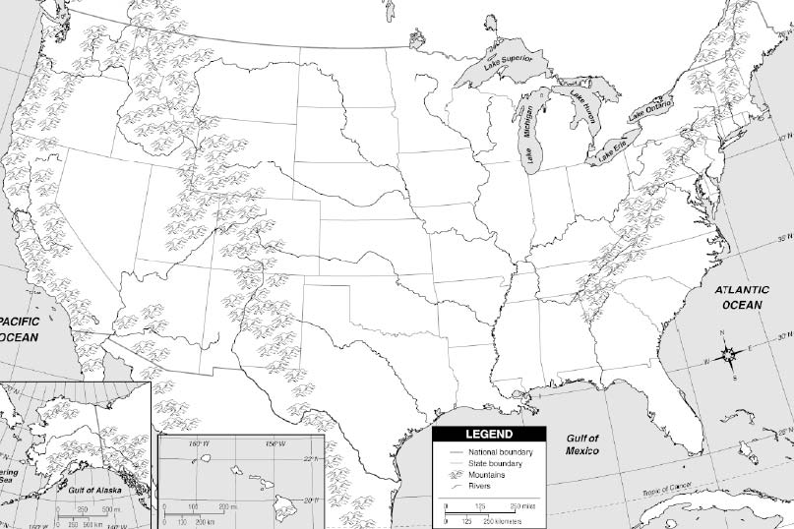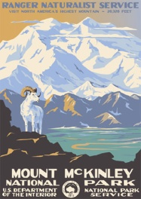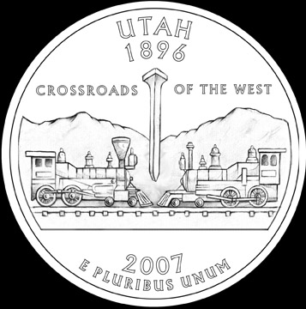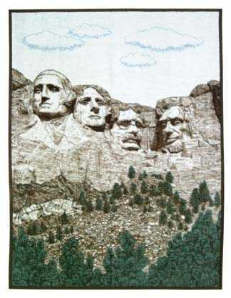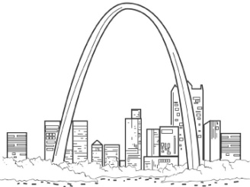

Meet Me At . . .

Have different classmates sign in each location on the map. No one can sign more than one box. When we have partner work, you will be told to work with your “White House” partner or “Grand Canyon” partner, etc.

The White House

________________________

The Alamo

_____________________________

Mt. McKinley

_________________________________

Boston

________________________

Mt. Rushmore

__________________________

Golden Gate Bridge

_______________________

St. Louis Arch

__________________________

Statue of Liberty

________________________

Promontory Point

_______________________