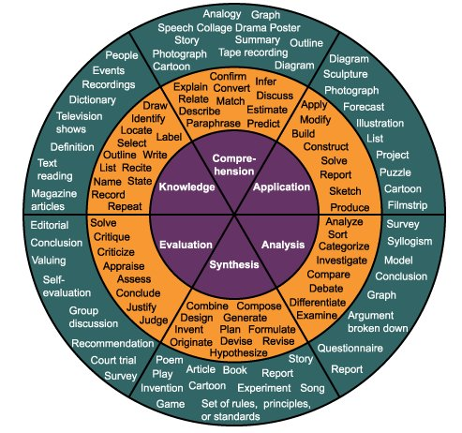
Action Words for Higher Order Questioning – Verbs for Learning
Knowledge | Comprehension | Application | Analysis | Evaluation | Synthesis
Define | Explain | Solve | Analyze | Reframe | Design
Identify | Describe | Apply | Compare | Criticize | Compose
Describe | Interpret | Illustrate | Classify | Evaluate | Create
Label | Paraphrase | Modify | Constrast | Order | Plan
List | Summarize | Use | Distinguish | Appraise | Combine
Name | classify | Calculate | Infer | Judge | formulate
State | Compare | Change | Separate | Support | Invent
Match | Differentiate | Choose | Explain | Compare | Hypothesize
Recognize | Discuss | Demonstrate | Select | Decide | Substitute
Select | Distinguish | Discover | Categorize | Discriminate | Write
Examine | Extend | Experiment | Connect | Recommend | Compile
Locate | Predict | Relate | Differentiate | Summarize | construct
Memorize | Associate | Show | Discriminate | Assess | Develop
Quote | Contrast | Sketch | Divide | Choose | Generalize
Recall | Convert | Complete | Order | Convince | Integrate
Reproduce | Demonstrate | Construct | Point out | Defend | Modify
Tabulate | Estimate | Dramatize | Prioritize | Estimate | organize
Tell | Express | Interpret | Subdivide | Fine errors | Prepare
Copy | Identify | Manipulate | Survey | Grade | Produce
Discover | Indicate | Paint | Advertise | Measure | Rearrange
Duplicate | Infer | Prepare | Appraise | Predict | Rewrite
Enumerate | Relate | Produce | Break down | Rank | Role-play
Listen | Restate | Report | Calculate | Score | Adapt
Observe | Select | Teach | Conclude | Select | Anticipate
Omit | Translate | Act | Correlate | Test | Arrange
Read | Ask | Administer | Discover | Conclude | choose
Recite | Cite | Articulate | deduce | conclude | choose
Record | Discover | Chart | Devise | Consider | Collaborate
Repeat | Generalize | Collect | Diagram | Critique | Collect
Retell | Give examples | Compute | Dissect | Debate | Devise
Visualize | Group | Determine | Estimate | Distinguish | Express
 | Illustrate | Develop | Evaluate | Editorialize | Facilitate
 | Judge | Emply | Experiment | Justify | Imagine
 | Observe | Establish | Focus | Persuade | Infer
 | Order | Examine | Illustrate | Rate | Intervene
 | Report | Explain | Organize | Weigh | Justify
 |  | Represent | Interview | Outline | Make
 |  | Research | Judge | Plan | Manage
 |  | Review | List | Question | Negotiate
 |  | Rewrite | Operate | Test | Originate
 |  |  | Show | Practice | Propose
 |  |  | Trace | Predict | Reorganize

