SundayReview | OPINION

The Eviction Economy
By MATTHEW DESMONDMARCH 5, 2016

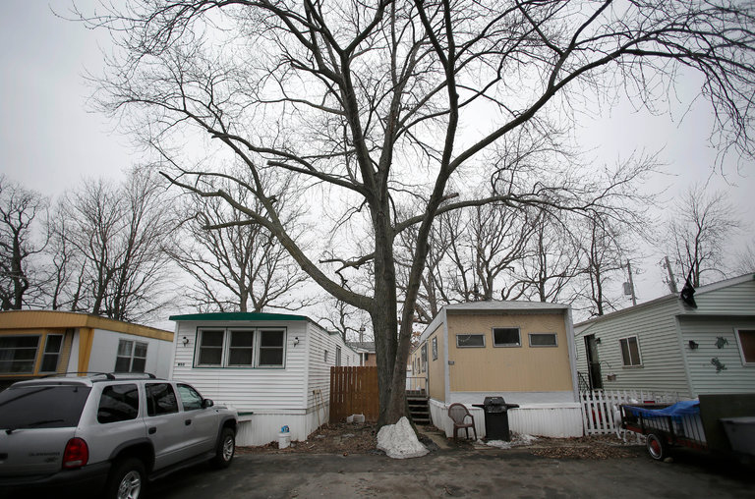
The College Mobile Home Park complex in Milwaukee. CreditJoshua Lott for The New York Times
I FIRST met Larraine when we both lived in a trailer park on the far South Side of Milwaukee. Fifty-four, with silvering brown hair, Larraine loved mystery novels, “So You Think You Can Dance” and doting on her grandson. Even though she lived in a mobile home park with so many code violations that city inspectors called it an “environmental biohazard,” she kept a tidy trailer and used a hand steamer on the curtains. But Larraine spent more than 70 percent of her income on housing — just as one in four of all renting families who live below the poverty line do. After paying the rent, she was left with $5 a day.
Under conditions like these, evictions have become routine. Larraine (whose name has been changed to protect her privacy) was evicted after she borrowed from her rent money to cover part of her gas bill. The eviction movers took her stuff to their storage unit; after Larraine was unable to make payments, they took it to the dump.
Those of us who don’t live in trailer parks or inner cities might think low-income families typically benefit from public housing or some other kind of government assistance. But the opposite is true. Three-quarters of families who qualify for housing assistance don’t get it because there simply isn’t enough to go around. This arrangement would be unthinkable with other social services that cover basic needs. What if food stamps only covered one in four families?
America stands alone among wealthy democracies in the depth and expanse of its poverty. Ask most politicians what we should do about this, and they will answer by calling for more and better jobs. Paul Ryan, the Republican speaker of the House, thinks we need to do more to “incentivize work.” Hillary Clinton, the front-runner for the Democratic presidential nomination, thinks we should raise the minimum wage. But jobs are only part of the solution because poverty is not just a product of joblessness and low wages. It is also a product of exploitation.
Throughout our history, wage gains won by workers through organized protest were quickly absorbed by rising rents. As industrial capitalists tried to put down the strikes, landlords cheered workers on. It is no different today. When incomes rise, the housing market takes its cut, which is why a two-bedroom apartment in the oil boomtown Williston, N.D., was going last year for $2,800 a month and why entire capital-rich cities like San Francisco are becoming unaffordable to the middle class. If rents rise alongside incomes, what progress is made?
Poverty is no accident, an unintended consequence from which no one benefits. Larraine’s rent money went to Tobin (also a pseudonym). A second-generation landlord, Tobin was 71, unsmiling and fit. His tenants waited tables at diners or worked as nursing assistants. Some received disability like Larraine or other forms of welfare, sometimes supplementing their checks by collecting aluminum cans.
Running one of the poorest trailer parks in the city had its challenges, like dealing with mental illness, addiction and domestic violence. Every so often, tenants wrecked their trailer the night before being evicted. Tobin had a way of dealing with that. He’d pay one of his tenants $20 to clean up the mess, then offer prospective new families the “Handyman Special,” a free mobile home as long as they paid “lot rent.” Lot rent was the same amount as rent, except the new “owners” would be responsible for maintenance. A family could move their trailer elsewhere, but in reality no one could afford to. When families fell behind in lot rent and were evicted, they inevitably left their trailer behind. Tobin would reclaim it as “abandoned property” and give it to someone else.

