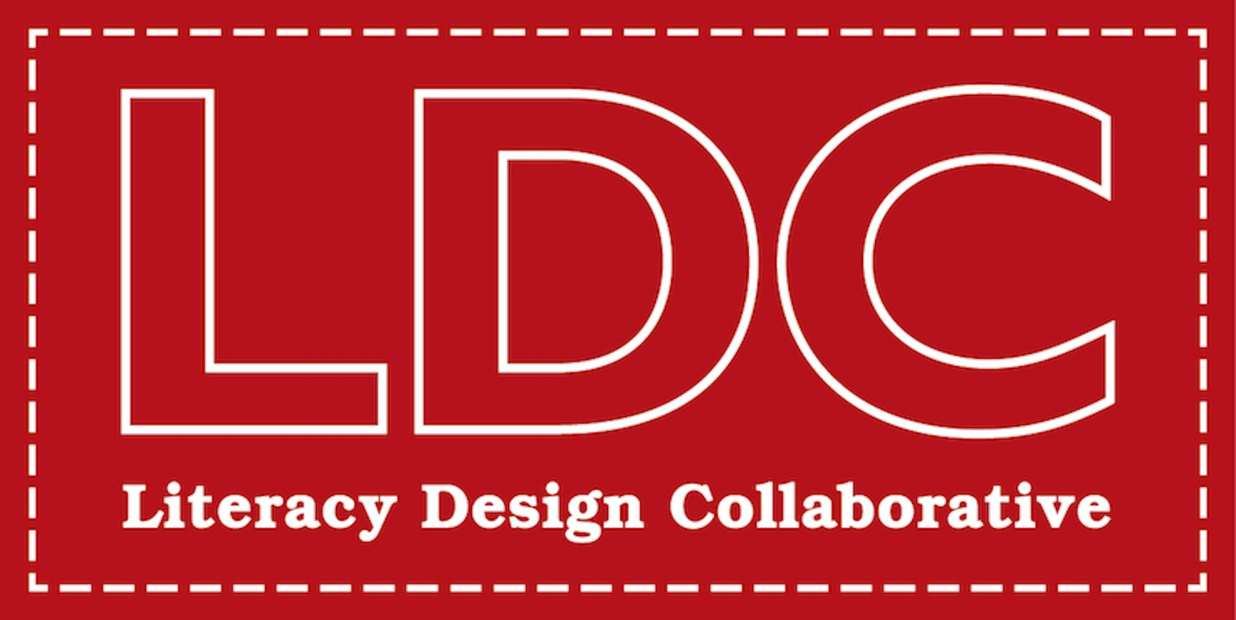

As you watch the “Literacy Matters” video, list key words/concepts you notice in the following areas:
Student Engagement | Content Learning
Teacher Planning | Student Results/Outcomes

