RESPONSE GROUPS FEEDBACK
My Group: ________________________________________________________________________________
STARS

WONDERS
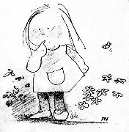

WISHES
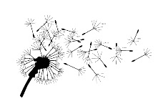

MY NEXT STEPS

